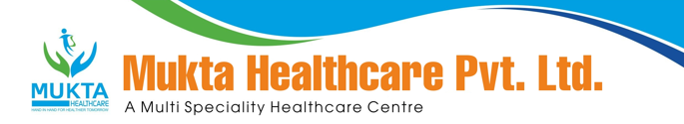

**MONTHLY BIO-MEDICAL WASTE REPORT**

For the Month of Mar,2025

1. Name of the Health Care Unit: Mukta Nursing Home
2. Address: Medical More, Sarada pally, Shiv Mandir, Siliguri 734011, Contact No: 9733533535
3. Category-wise (As per Schedule of the Rule) generated and quantity for the month of **Mar,2025**.

|  |  |  |
| --- | --- | --- |
| Category | Count(Bags) | Waste Quantity(Kg) |
| YELLOW | **20** | **35.00** |
| RED | **18** | **32.50** |
| WHITE(Sharp) | **0** | **0.00** |
| Blue(Glass) | **0** | **0.00** |

1. Category-wise total quantity of waste sent to common BMW treatment facility.
   1. Incineration/Burial (yellow bags):**35.00** Kg.(Own facility/Common BMW treatment

facility)

* 1. Auto clave/Microwave:

(a)Red Bag: **32.50** Kg(Own facility/Common BMW treatment facility}

(b)Sharp Container **0.00** kg.(Own facility/Common BMW treatment facility)

1. Any other relevant information.
2. Certified that the above report is for the month of **Mar,2025**.

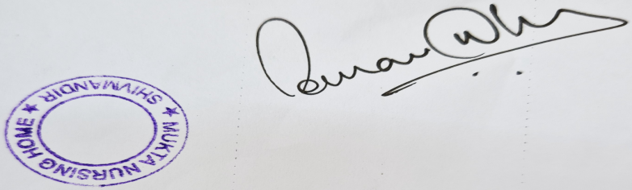

Dr Sourav Dhar

Managing Director

